Decorator pattern adds additional functionality an existing object without altering its structure.

This type of design pattern comes under structural pattern as this pattern acts as a wrapper to existing class.

This is an good example of Open/Closed design principle

Design1 or Release1 software
Concrete Class implements Interface1
After some period Design2 or Release2 software
Decorator Abstract Class extends Interface1 (to make additional behavior)
New Concrete Class implements Decorator Abstract Class holds Interface1 reference (composite or HAS A relation). The purpose of holding Interface1 reference is so that the new concrete class will have Design1 state and Design2 behavior.

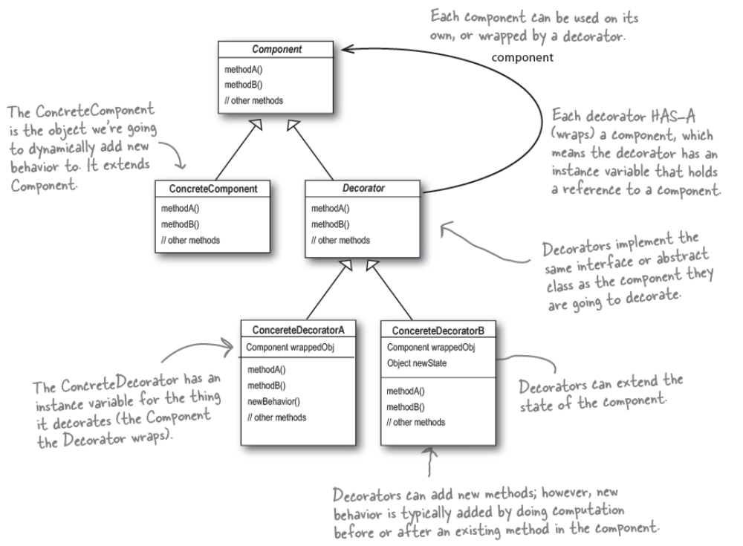

package com.sample.designpattern;

interface Calculator {
int add(int n1, int n2);
}

class BasicCalculator implements Calculator {
@Override
public int add(int n1, int n2) {
return n1+n2;
}
}

abstract class DecoratorCalculator implements Calculator {
Calculator calc;
public DecoratorCalculator(Calculator calc) {
this.calc = calc;
}

@Override
public int add(int n1, int n2) {
return calc.add(n1, n2);
}

}

class ScientificCalculator extends DecoratorCalculator {

public ScientificCalculator(Calculator calc) {
super(calc);
}

public int square(int n1, int n2) {
return n1*n2;
}

}
public class DecoratorPatternTest {

public static void main(String[] args) {

ScientificCalculator c = new ScientificCalculator(new BasicCalculator());
System.out.println(c.add(10, 20));
System.out.println(c.square(10, 20));
}

}

